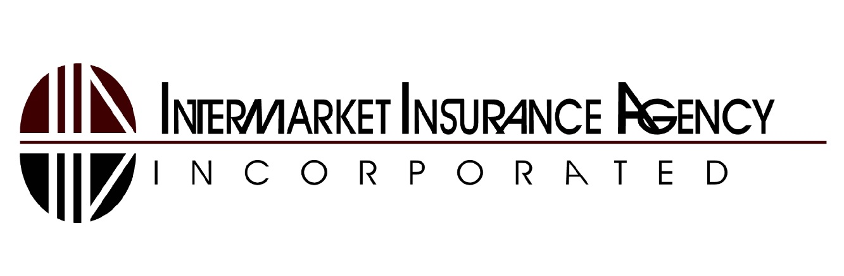

Available Coverages
The following table describes coverages available for restaurant businesses:
The below coverage descriptions are for informational purposes only

Coverage | Type | Description
General Liability | Third Party | This coverage protects your restaurant from lawsuits that might result from slip and falls by customers, sickness caused from food served, and damage to others' property caused by your daily operations.
Employment Practices Liability | Third Party | This coverage protects your restaurant from discrimination, sexual harassment, and employment related lawsuits brought by current, potential, and former employees.
Liquor Liability | Third Party | This coverage protects your restaurant from lawsuits involving alcohol which might result from someone who is injured or whose property is damaged after consuming alcohol provided by your business. This coverage provides legal defense and funds for lawsuit settlements up to the policy limits.
Workers' Compensation | N/A | This coverage protects your restaurant when employees suffer injuries, illness or death related to their jobs. It pays employees for medical care, disability compensation, or rehabilitation (e.g. physical therapy). When death occurs, it pays employee's family for funeral costs and survivor benefits.
Off Premises Utility Interruption  Off Premises Utility Interruption (Cont’d) | First Party | This two part coverage protects your restaurant if a power or utility failure occurs off your facility. The first part covers business property, such as computers, machinery, and other equipment, that is damaged as a result of the utility failure. The second part reimburses for lost income that results from your restaurant being shut down due to the utility failure. Standard property and business income coverage normally exclude utility failures.  Utility Services might include:  - water supply (i.e. plumbing stations, water mains, water treatment plants)  - communication supply services (i.e. telephone, radio, or television services, internet)  - power supply services (i.e. power plants, switching stations, transmission lines, substations, transformers, and local power lines)
Business Income & Extra Expense | First Party | This two-part coverage protects your restaurant from a temporary shutdown resulting from property damage to your facilities. Business Income reimburses your business for earnings lost during a shutdown period, while Extra Expense provides additional funds to keep your business operational (i.e. to rent a temporary facility while your building is repaired).
Employee Theft | First Party | This coverage protects your restaurant in the event an employee or volunteer steals, destroys, or loses money or securities.
Spoilage | First Party | This coverage protects your restaurant when perishable inventory at your facility, such as meat, fruit, and vegetables, spoils and becomes unusable due to a change in the controlled conditions. Spoilage might result from a mechanical failure of the refrigeration system, humidity control device, or other equipment for keeping perishable goods fresh. Spoilage could also result from a power failure, either on-site or off-site, outside of your control, which prevents refrigeration equipment from operating.  The coverage provides reimbursement for spoiled goods.
Other coverages might include: Umbrella Liability, Building and Personal Property, Hired & Non Owned Automobile Liability, Flood

Loss Examples
The following table provides loss examples a restaurant might experience. Each example includes a description and list of coverages that apply.
Loss | Description | Applicable Coverages
Customer was served alcohol at your restaurant and later caused an auto accident | Your customer that had been served alcohol at your restaurant caused an auto accident which resulted in bodily injury to the occupants of the other vehicle. Your restaurant is sued by the injured parties due to the alcohol being served by your business. | Liquor Liability, Umbrella Liability
Hurricane causes a power outage | A power outage occurred off your premise and was outside of your control. It forced you to close your business for a week, losing profits, and incurring costs for the spoiled food. | Off Premises Utility Interruption, Business Income & Extra Expense, Spoilage, Windstorm
Kitchen fire breaks out damaging equipment | The kitchen fire was the result of a faulty circuit in one of your ovens. The damage also included $3,000 in unprepared food and $5,000 to the building structure, including the ceiling, insulation, and attic. | Building and Personal Property
Restaurant customer falls while walking to their table | A bowl of soup had spilled on the floor; your customer didn't see it, slipped and fell, and broke their hip. A trip to the hospital resulted in tens of thousands in medical bills and a lawsuit against your restaurant. | General Liability, Umbrella Liability
Theft of money by employee | For many years your bookkeeper secretly had checks issued to fake companies from your business account showing services were provided for your business. After an audit was performed, it was realized the money was being stolen by the bookkeeper. | Employee Theft

